Short course for Chinese students
Faculty of Pharmacy, University of Szeged, Hungary

Name of the course: Introduction to Pharmaceutics

Description of the course: Participants get an insight into the past, present and future of European pharmaceutics through 9 interesting subjects. Besides the theoretical training, students have the possibility to visit working laboratories, get a sense of the excitement of discovery. The course includes two tours to the most beautiful parts of Hungary.
Duration: 5 weeks (from the end of May to the end of June, and from the beginning of September to the beginning of October), 5-6 hours/day except Saturday and Sunday; 90 hours of lecture, 14 hours of institutional visit, tours (1 day and 3 days/2 nights) in Hungary.
Deadline for registration: May 31 each year.
Fee of the course (travel expenses, accommodation and catering are not included):
104 hours training (9x10 hours theoretical + 7x2 hours institutional visit:
1000 USD or 765 €
Tours (1 day+ 3 days/2 nights) 440 USD or 315 €
Total amount: 1440 USD or 1080 €
Deadline for the payment: April 30 and July 15 each year
Requirements: completed high school studies, moderate/good English skills
Contact person: Róbert Gáspár PharmD, PhD, Vice Dean
E-mail: gaspar@pharm.u-szeged.hu; office@pharm.u-szeged.hu
Phone: +3662341971; +3662545022
Fax:+3662546424

Subjects of the course:
1. Phytotherapy - plants in the modern medicine (2 credits)  Lecturer: Dezső Csupor PharmD, PhD senior lecturer | 
The aim of the subject is to give an overview of the application of plant-based medicinal products in the contemporary medicine. As an introduction, the roots of the modern phytotherapy (TCM, Ayurvedic medicine, other non-European and European traditional medicinal systems) and the frontiers of phytotherapy (homeopathy, aromatherapy etc.) are also presented. The main focus is on the evidence-based application of medicinal plants, therefore the current knowledge on the pharmacological and clinical investigations is discussed in detail. The syllabus of the course is organized according to the pharmacological characteristics, clinical applications of the plants.

2. History of Pharmaceutics (2 credits)  Lecturer: Tamás Sovány PharmD, PhD, assistant professor | 
The aim of the subject is to introduce the history of pharmaceutics over the centuries. The course introduces the development of pharmaceutics from the great antique cultures (China, India, Egypt) to nowadays, including the medicine in the antiquities, medicine in the ancient Greek culture (The story of Asclepius and the tuitions of Hippocrates), medicine in the medieval (herbal gardens in the monasteries, appearance of the first pharmacies), the age of alchemy and development of the pharmaceutical industry.

3. Illegal drugs from nature (2 credits)  Lecturer: Attila Hunyadi PharmD, PhD, senior lecturer | 
The subject aims to give a brief overview on the most important mind-altering drugs originated from natural sources, including their chemical composition, pharmacology, occasional ethnopharmacological relevance, abuse trends and legal status. Popularity of such drugs originates from natural curiosity, which is heavily encouraged by the aggressive illegal (and sometimes legal) distribution and the easy-to-obtain but frequently false, misleading information on the Internet. Due to the enormous amount of available information with questionable quality, scientifically well-supported knowledge on the subject has become of particular importance for the practicing pharmacist and healthcare professionals in general.

4. General laws in natural science (2 credits)  Lecturer: György Dombi PhD, professor | 
The aim of this subject is the introduction into the field of sciences through the laws describing the material systems. The principal objectives of this course is to summarize and integrate the laws of mathematics, physics and chemistry, their consequences and with this summarize and organize the knowledge from the high school studies. The main goal of the course is to help students starting their university studies. At the end of the course, the students are expected to: (1) show the solid knowledge of the principles of the physical and chemical laws; (2) understand the basis of the laws of sciences, their principles and consequences; (3) understand the use of these laws in the different fields of sciences.

5. Natural treatments (2 credits)  Lecturer: Róbert Gáspár PharmD, PhD, associate professor | 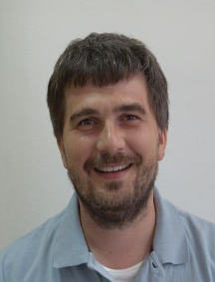
The aim of the subject is to provide knowledge on the traditional healing, natural treatment protocols and health promotion procedures. The students get knowledge to be able to take sides between evidence based and unscientific natural treatments. The following topics are discussed during the lectures: Physiotherapy (thermal-, light-, electro-, ultrasound-, hydro-, balneo-, and exercise therapy). Nutrition (the role of special diets in treating and preventing diseases). Non-scientific or not completely proved methods (osteopathy, homoeopathy, energy healing). European perspectives of Chinese and Ayurvedic remedies.

6. Basic communication skills in pharmacy practice (2 credits)  Lecturer: Ildikó Csóka PharmD, PhD, associate professor | 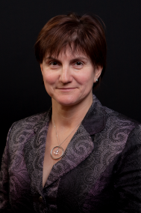
Basics of interpersonal communication; verbal and non-verbal elements.
Importance of human relations, psychotherapy and communication in patient-centered health care. Human personalities, characterization, patient types and their handling in pharmacy. Pharmacists’ communication during drug dispensing and patient consultation. Role of communication in improving patient adherence and satisfaction. Situations, examples within the topic

7. Dietary supplements (2 credits)  Lecturer: Attila Ványolós PharmD, PhD, assistant professor | 
Dietary supplements are increasingly popular among consumers, more and more people routinely using them. They are regulated as a class of foods, not as drugs; in consequence they are not screened for safety and effectiveness. EU law does not permit dietary supplement labels to contain drug claims: supplements are not intended to treat, prevent or cure diseases. In spite of the regulation, consumers are using dietary supplements to maintain or improve health. But while many supplements may be beneficial, they are not without risks. Several dietary supplements have been associated with side effects: persons “self-medicating” with dietary supplements should be aware of the fact that some of these products may interact with common prescription drugs. During this course the most important dietary supplement ingredients – grouped according to the health claims accepted by the European Food Safety Authority – are discussed. The aim of this course is to highlight the most important features of nutritional supplements’ use including information on benefits as well as possible risks, providing undergraduate students an overall picture of dietary supplements.

8. Milestones in drug discovery – A chemical approach (2 credits)  Lecturer: László Lázár PharmD, PhD, associate professor | 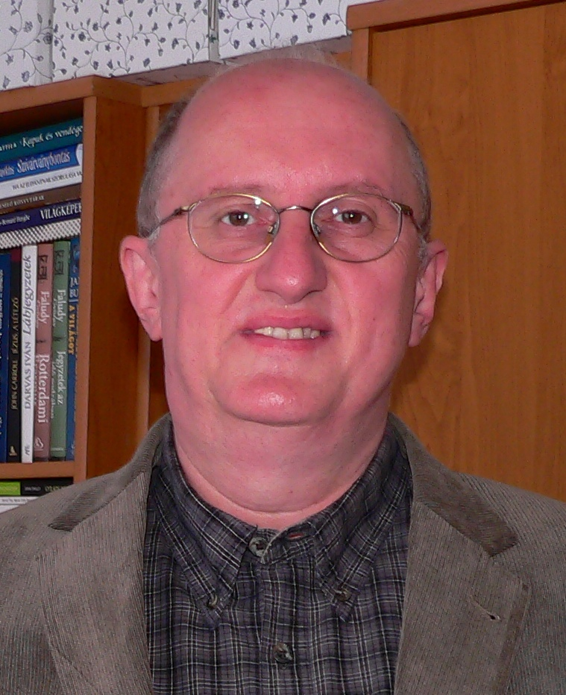
Creating new drugs to combat disease is a complex process in which chemistry plays a significant role including not only the synthesis or isolation of new compounds but also the understanding their biological effects at a molecular level. The most important events of drug discovery, from ancient observations to current structure-based methodologies, will be discussed in the lectures from chemical point of view. The following topics will be covered during the course: From casual observations to systematic search. The role of serendipity in drug discovery. Drugs from natural products. The first synthetic drugs. The birth of chemotherapy. Rationalizing the drug discovery process. Some examples of structure-based drug discovery. Prodrugs. Biopharmaceuticals.

9. Pharmacists' role in medication and patient safety (2 credits)  Lecturer: Péter Doró PharmD, PhD, associate professor | 
Pharmacists have a key role in ensuring the safe use of medication, and improving patient safety. A clinical pharmacist, as a member of the health care team, can be involved in the decision making of selecting the most appropriate medication for the patients, and also the clinical pharmacist ensures that the right patients receives the right medication at the right time. A community pharmacist is the final health care professional, who sees the patient before the patient receives the medication; therefore the pharmacist can detect any medication error and also the pharmacist provide adequate advice to the patient on the safe use of medication, as part of the pharmaceutical care activities. The classes give a brief insight into these special activities of the pharmacists.

10. Institutional visit at Faculty of Pharmacy (2 credits)

Visiting the 7 institutes of the Faculty (2 hours each), looking around in the laboratories during scientific experiments, meeting with qualified experts from different fields of pharmaceuticals.

Total credits of the course: 20. Credits are scored after successful final test at the end of the course.

