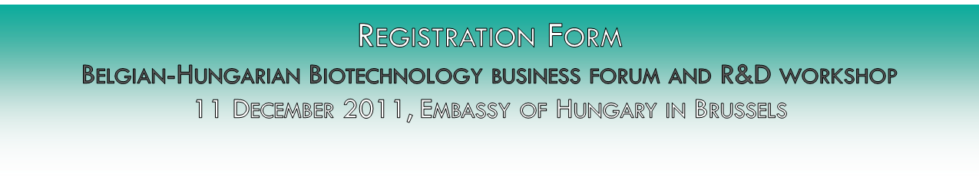
Company/organization:
Optional
Insert the logo/photo of the company/organization or send it via e-mail in jpeg/tiff format.

Address: City ZIP………………………….
Street Number……..
Website:
Contact person:
Email address:
Phone number:
I wish my company profile to be included into the event brochure*: YES/NO

*If you wish your company/organization profile to be included into our event brochure please fill in the boxes below presenting your main activities and your interest for cooperation in English. The event brochure will be distributed to the participants in order to facilitate bilateral meetings and networking.

Description of activity (max: 150 words)

Interest for cooperation/Project idea (max: 100 words)

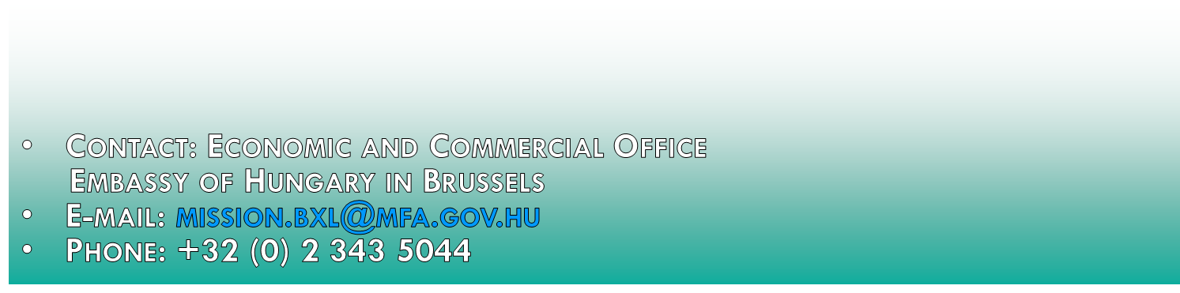

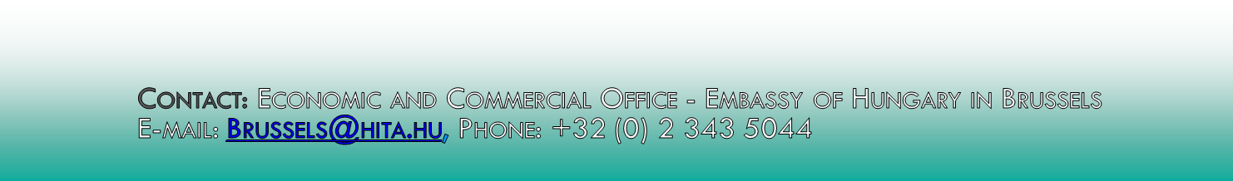

Please return this form until the 24th of November 2014. Places are limited.

